

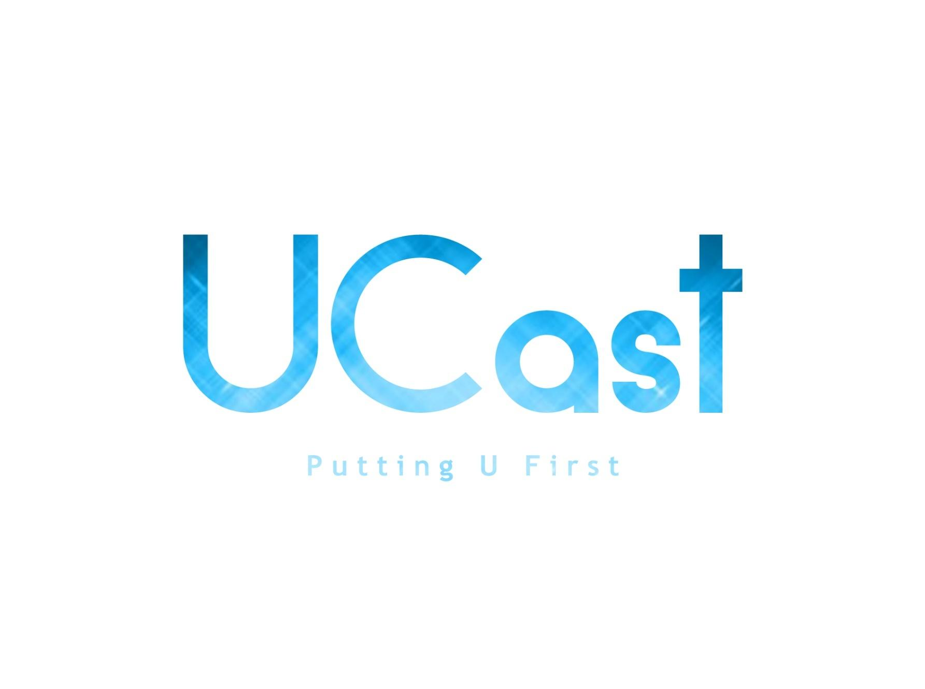

|  |  |
| --- | --- |
| Jenny Freeley | 13403352 |
| Blair Flinn | 15200017 |
| Fergal Lonergan  Michael Rodgers  Bill Shannon | 13456938  13418412  13519393 |

**UCast**

**EEEN40300: Entrepreneurship in Engineering**

Table of Contents

Introduction: 3

Problem we are solving: 3

Market Size: 3

Revenue Model: 4

Customer Discovery: 4

Competitive Analysis: 5

Hypothesis Validation & Learnings: 6

Our Product: 6

Competitive Advantage: 7

Team Building & Dynamics: 8

Challenges: 9

Insights: 9

Reflection: 10

Future Plans: 10

References 10

# Introduction:

As a team, UCast approached the problem of outdated orthopaedic casts that are still being used by hospitals today. The main reason we approached this problem is that two of our team members had worn a cast within the last 12 months and found it very difficult to deal with. Both Michael and Blair were motivated to find a superior solution to healing a broken arm.

At first UCast investigated 3D printed casts as a solution, however, as we became more familiar with the process and teachings of this module, we began to iterate quickly away from this solution as many issues came to light.

# Problem we are solving:

The problem we are solving is the restrictions, discomforts and healing time associated with current orthopaedic casts. Fibreglass is an outdated technology that is simply inadequate, we are bringing orthopaedic casts into the 21st century. Our initial concept was a 3D printed cast, however when we left the classroom and interviewed a total of 55 people of all ages and professions to gain a deeper understanding of the problem, we found that this solution was not sufficient; the solution must satisfy not just the user and the buyer, but all customer archetypes. We took our initial idea and altered it accordingly, highly influenced by what we had learned outside of the classroom, yet also highly influenced by innovative thinking, with the sole objective of creating a novel product that would satisfy all customer archetypes. This led us to our final concept, which is outlined in section 7.

# Market Size:

From our research we found that an orthopaedic fracture occur every 5 seconds, with the wrist being the most common fracture location [1]. The annual number of fractures in the EU will rise from 3.5 million in 2010 to 4.5 million in 2025, corresponding to an increase of 28% [2]. There are 6.3 million fractures annually in the US [1]. There are approximately 7,154 hospitals in Europe [3] and 5,627 hospital in the US [4] that deal with orthopaedic injuries. These are our target markets.

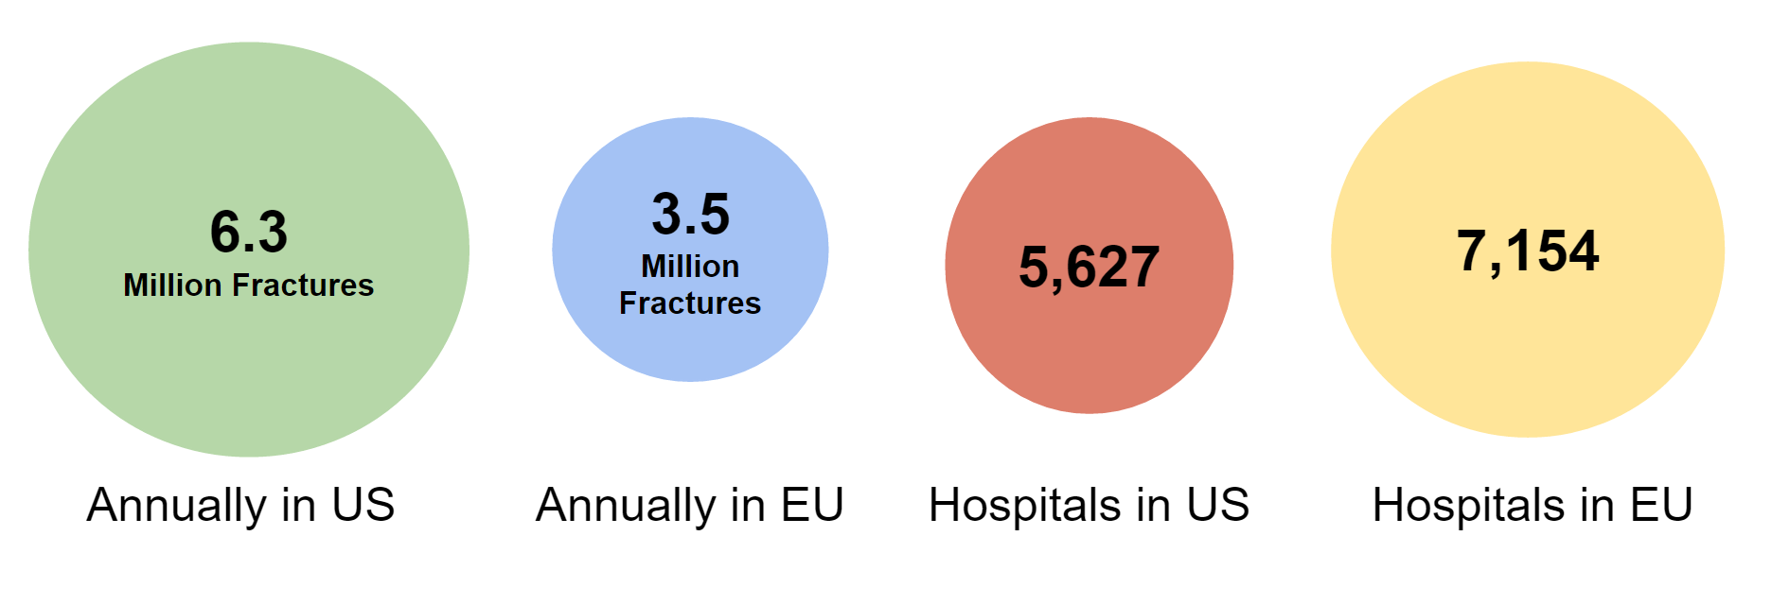

*Figure 1 - UCast Target Market*

# Revenue Model:

We had learned quite early on that our customers highly valued what our product could offer them on a day-to-day basis, i.e. the ability to wash, wear their favourite clothes and the possibility of reducing their healing time. As a result, we value priced our product at €220. This figure was reached after our customer research informed us that patients, our end-users, were willing to pay around €300 for our product. However our buyers, the hospitals, currently make €50 profit on the current 3M fiberglass casts. By value pricing our casts at €220 the hospitals then had the opportunity of making €80 profit.

Our second option was an up-front annual subscription of €17,500 and then sold the casts at €150 per unit. This was devised to entice the hospitals further into purchasing our product. Our research led us to discover that on average there are 628 upper arm and wrist orthopaedic injuries per hospital in Ireland annually. With the second option, after selling 250 casts to patients, the hospital would save on the original option. We would also then use the up-front payment to pay off our own up-front costs.

# Customer Discovery:

Customer interviews played a huge part in the entire process for our group. They were an essential aid to defining the problem we were solving. From talking to customers, we were able to instantly find out what the biggest issues associated with the current cast are. We then designed our cast with the intention of tackling the issues so that our product was something that customers needed and wanted.

Our target customers were also chosen as a result of what we learned in customer interviews. We were able to validate or invalidate assumptions that we made with regards to who might be interested in our product, and found that there were definite potential customers in self-employed people and elite athletes. To satisfy all of our customer archetypes, we also had to consider the hospitals who would be purchasing our product. We gained invaluable insights through interviewing healthcare professionals with regards to the length of the process of getting machinery into hospitals and the standards that need to be met by a medical product so that it can be implemented in the market.

# Competitive Analysis:

Our two main competitors are Osteoid and Xkelet, companies who sell 3D printed casts. Osteoid has also partnered with an ultrasound company, and include this technology with their product.

Xkelet has already started testing its cast on two patients and started clinical trials in September. They have also secured contracts with two of the leading health insurers in Spain.

Osteoid has partnered with Exogen whose ultrasound devices have been passed by the NHS last year and have been proven to heal fractures up to 38% faster with using the device for 20 minutes a day. Osteoid has been contacted by numerous government and privately owned clinics in the U.S. who are looking to start trials immediately. Numerous patients have also contacted the company who want a cast right away and even though they are not yet FDA approved.

The success seen by our competitors shows how there is an existing market for lightweight, waterproof, breathable casts. This supports the hypothesis that patients are willing to spend more money on a superior cast as was validated by our customer interviews. We believe our solution is superior to both of the aforementioned companies as we have far less upfront costs pertaining to 3D printers and our solution is more cost effective. It also has a much shorter waiting time for the patient and can be applied in approximately 30 minutes.

# 

# Hypothesis Validation & Learnings:

Our first hypothesis was that if a 3D-printed cast could be manufactured as a replacement for traditional orthopaedic casts at an UCast factory/clinic or hospital, then the customer would buy it as it offered numerous advantages. However, after interviewing our potential customers and undergoing web research we found that 3D printed casts were simply too slow to mass-market and could not compete with the <30min installation time of 3M Fiberglass casts. Following this, we developed a new hypothesis focused around speed, efficiency, and costings. Our final hypothesis was that if an alternative cast was delivered to the customer and solved their weight/size/smell/waterproof concerns, then the actual shape, material, and manufacturing method was trivial to the end user. It was this final hypothesis that was validated with UCast’s prototype.

# Our Product:

Our product is a revolutionary cast designed to stabilise and hold anatomical structures in place to facilitate the healing of fractured bones. The design grants access to the skin which allows users to avail of the latest healing techniques such as ultrasound therapy. It consists of a hollow elastic silicone sleeve that is placed around the afflicted limb. This is then injected with a Poly (methyl methacrylate) solution, “HydroSet” [5], to provide the mechanical competency required. HydroSet is an injectable, isothermic, fast-setting, osteoconductive hydroxyapatite bone substitute, designed to set under normal body wet-field conditions. It is biocompatible and FDA approved. The following schematic illustrates how our cast is constructed:

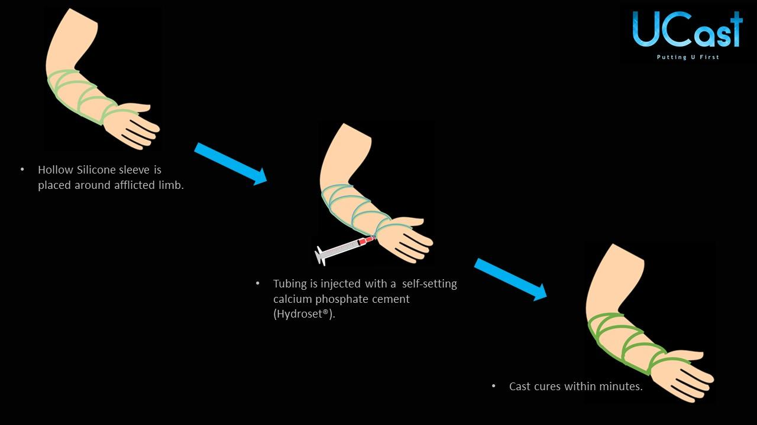

*Figure 2 - UCast Installation Method*

# Competitive Advantage:

Our cast had to deliver on a myriad of aspects in order for it to be successful. The 3M cast is currently very quick to fit onto a patient’s arm, as well as being very cheap. We could not compete with how cheap the 3M cast is, however, we could ensure that our cast could be deployed as quick or faster. We have explained in our revenue model how we found a price that satisfied all parties.

3D Printed casts, like Xkelet or Osteoid, are not cheap or quick to deploy, costing between €300-€500 and, due to nature of 3D printing and checking the casts off-site, you usually don’t get fitted with your cast until the following day. However, what they do offer which the fiberglass casts do not, is a lightweight, waterproof, breathable, unobtrusive and ultrasound compatible option.

Our goal was to create a cast that delivered on all these aspects. By creating a product that could be deployed quickly, yet still deliver on being waterproof, lightweight, ultrasound compatible and unobtrusive, UCast, unlike our competitors, delivers on all the aspects that our customer segments expect of an orthopaedic cast.

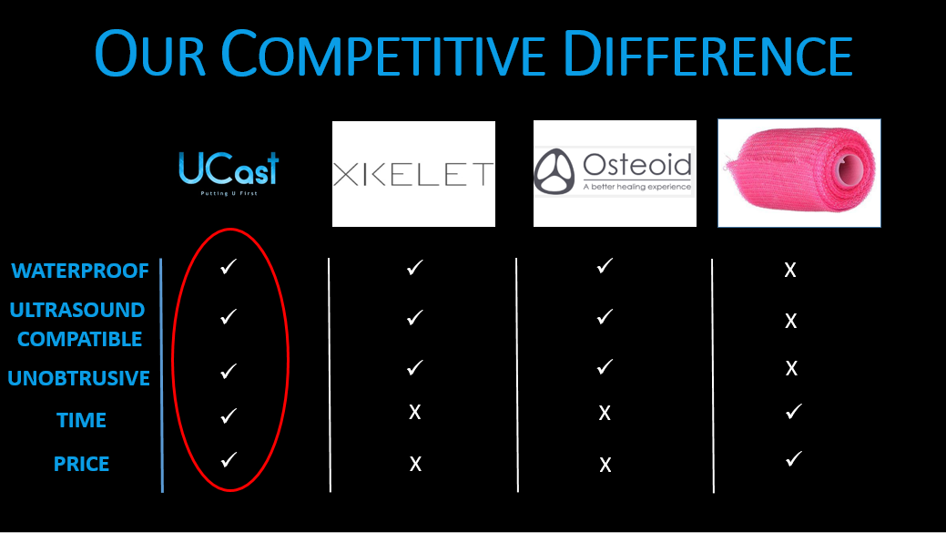

*Figure 3 - UCast Competitive Advantage*

# Team Building & Dynamics:

As a group we worked very well together. In general, we used a collaborative leadership style. The person who was presenting in class each week normally took the lead on decisions of what was to be done and ownership over the slides. During the process, some members were busier than others for particular weeks. Usually, we dealt well with this and those who had the time contributed more to our work that week. However, there were rare occasions when all team members had other priorities and as a result, we did not perform as well e.g. not meeting our interview quota for that week.

As the semester progressed, we improved at delegating certain tasks to individuals in the group. We soon each took on more specific roles, such as updating our business model canvas, continuing with the framing of our interview plans, interviewing potential customers, researching our competitors, devising our revenue model, etc.

# Challenges:

The key challenges for us as a group were attempting to shorten the historically long product lead-time associated with new medical devices. Originally, we were also faced with the challenge of attempting to get 3D printers into hospitals. Many consultants we talked to informed us that the process of getting new machinery into hospitals could take years. Due to these findings we iterated to a different design where no new machinery was required. We also used materials that are already FDA approved, and as our device would be classified as a Class I medical device due to its low risk, it could be sold to hospitals in as little as six months.

Another challenge we faced was staying motivated and driven throughout the 12 weeks. As students we are used to cramming towards the end of a semester and therefore the consistent workload forced us to develop superior organisational skills. With each group member facing their own exterior workload and deadlines, our communication skills were also pivotal in overcoming the challenge of staying on top of the week-to-week deadlines.

# Insights:

Insights proved extremely valuable to our team throughout this process. It was from our problem-focused, customer interviews with industry professionals, like orthopaedic consultants, medical device researchers, etc., that we obtained the greatest insights.

For example, after interviewing Dr. Declan Reedy, we discovered that it was necessary for our product to satisfy all customer archetypes including hospitals and patients. This led us to realise that the infrastructure surrounding 3D printed casts was a major factor in why products like Xkelet and Osteoid were not commonly used in Irish practice today, as in order for the process to work effectively, hospitals must invest heavily in 3D scanners, printers and training for their staff to use the new machinery.

Our customer interviews also led us to discover that certain customer archetypes value our product more than others. For example, self-employed people expressed very strongly how significantly it affects their business if they are forced to take prolonged absences from work. This issue was also seen with professional athletes who could miss an entire season should they be unfortunate enough to injure themselves. This enlightened us to realise that these specific subsets of our customers would be willing to pay large sums of money in order to return to work, or training, in the shortest time possible.

# Reflection:

If we were starting this process again, we would definitely start to contact persons of interest earlier for interviews. It was relatively easy to interview people who had previously experienced a fracture, however, it was much more difficult to interview experts on the subject, such as orthopaedic surgeons, hospital directors and consultants.

# Future Plans:

Our first step would be to validate our current design. Though we have iterated throughout our design process, there are still aspects of it that could be improved upon. Through speaking to medical device researchers, we know that the materials that we intend to use are FDA approved and fit for the purpose that we intend to use them for, however the putting together of these materials is something that is still to be decided. Clinical trials will be an essential part of the process for us to ensure that our product performs sufficiently. As our cast would be a class I medical device, we would only need to abide to general controls. We will proceed down the 510k regulatory route (Based on substantial equivalence) for CE and FDA applications so that our product would be viable to be sold in the Irish market. After all of this we would undoubtedly have to network with hospitals and clinics so that they would be willing to promote our product to their patients and to encourage them to purchase our casts at a greater volume.

# References

[1] - Evill, J. (2013). CORTEX. EVILL. Retrieved from http://www.evilldesign.com/cortex.

[2] - Hernlund E, Svedbom A, Ivergard M, Compston J, et. al. Osteoporosis in the European Union: Medical Management, Epidemiology and Economic Burden. A report prepared in collaboration with the International Osteoporosis Foundation (IOF) and the European Federation of Pharmaceutical Industry Associations (EFPIA). Arch Osteoporos 2013 8:136   
DOI 10.1007/s11657-013-0136-1

[3] - Number of hospitals in Western European countries; a 2005 and 2012 comparison - Medical Device Network. (2016). Medicaldevice-network.com. Retrieved from http://www.medicaldevice-network.com/features/feature48597/feature48597-2.html

[4] - Facts on US Hospitals. (2014). American Hospital Association. Retrieved from <http://www.aha.org/research/rc/stat-studies/fast-facts.shtml>.

[5] - Bone Substitutes - HydroSet : Stryker . (2016). Stryker.com. Retrieved from http://www.stryker.com/en-us/products/Orthopaedics/BoneSubstitutes/

# 